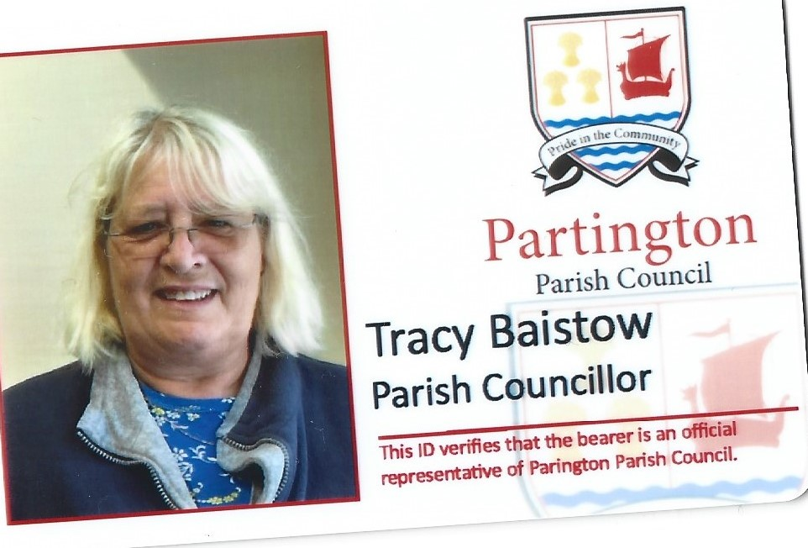
COUNCIL SURGERY DATES
PARTINGTON RAINBOW COMMUNITY CAFÉ
2 TO 4PM
THURSDAY 3RD APRIL 2025
THURSDAY 1ST MAY 2025
THURSDAY 5TH JUNE 2025
THURSDAY 3RD JULY 2025
THURSDAY 7TH AUGUST 2025
THURSDAY 4TH SEPTEMBER 2025
THURSDAY 2ND OCTOBER 2025
THURSDAY 6TH NOVEMBER 2025
THUESDAY 4TH DECEMBER 2025
THURSDAY 1ST JANUARY 2026 NO SURGERY
THURSDAY 5TH FEBUARY 2026
THURSDAY 5TH MARCH 2026

